Understanding Social Networking

While many types of social media web sites exist, a few are especially popular:

* Social networking site: Web site that enables people to share information about common interests, news, and events
  + Also known as social networks
  + Open to most anyone with restricted access to unknown users
  + Prewritten HTML or JavaScript code
* Blog: special-purpose Web site that enables one person or a small number of people to post news or updates
  + Usually focused on a narrow topic
* Microblog: site that shares aspects with both social networking sites and blogs
  + Twitter is an example

We will look at the following now:

* Integrate a Facebook account with a Web site
* Participate in social bookmarking
* Integrate a Twitter account feed
* Add a Twitter hash tag feed
* Participate in social bookmarking

Integrate a Facebook account with a website

Make sure you have a Facebook account before doing this.

1. Login to Facebook
2. Open a separate browser window and open the following page: <https://developers.facebook.com/docs/plugins/>
3. Locate and click the Like Box Link from the left side of the page
4. Enter <http://www.facebook.com/cengagebrain> into the URL textbox as shown and make sure friends faces is checked

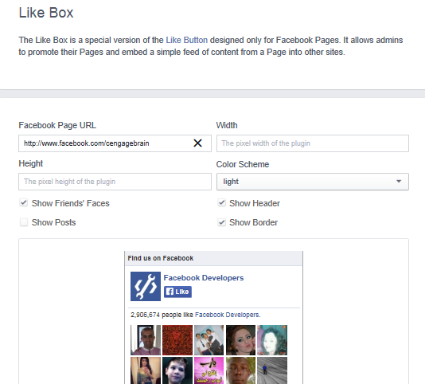

1. Click on the Get Code button.

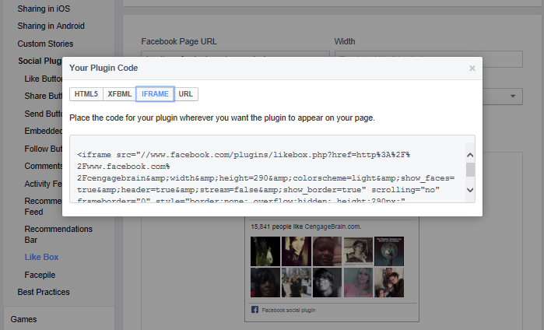

1. Select iframe
2. Click once into the code to select it and right click and copy.
3. Paste your code into your html file. You made need to modify the code to include “http” as highlighted.

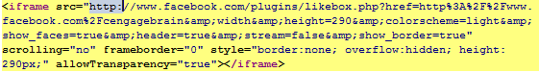

1. Save and run.
2. Go back to Facebook and deselect show friends faces and select posts.

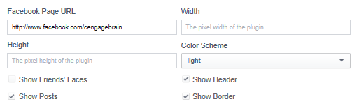

1. You have to generate new code and copy to your html file as before.

Participate in social bookmarking

Add a Like button

The Like button is the quickest way for people to share content with their friends.

A single click on the Like button will 'like' pieces of content on the web and share them on Facebook. You can also display a Share button next to the Like button to let people add a personal message and customize who they share with.

[What does it mean to like a Page or content off of Facebook?](https://www.facebook.com/help/131263873618748)

When you click Like on a Facebook Page, in an advertisement, or on content off of Facebook, you are making a connection. A story about your like will appear on your Timeline and may also appear in your News Feed. You may be displayed on the Page you connected to, in advertisements about that Page or in social plugins next to the content you like.

You may see updates to in your feeds and the feeds of your friends from Pages you like. You may also receive messages. Your connection to the page may also be shared with apps on the Facebook Platform.

1. Load the following address again: <https://developers.facebook.com/docs/plugins/>
2. Select the Like Button from the left side of the screen.
3. Enter <https://facebook.com/cengagebrain> into the URL, 100 into the width, button_count as the Layout.
4. Deselect Show Faces.
5. Click on Get Code, select and copy.

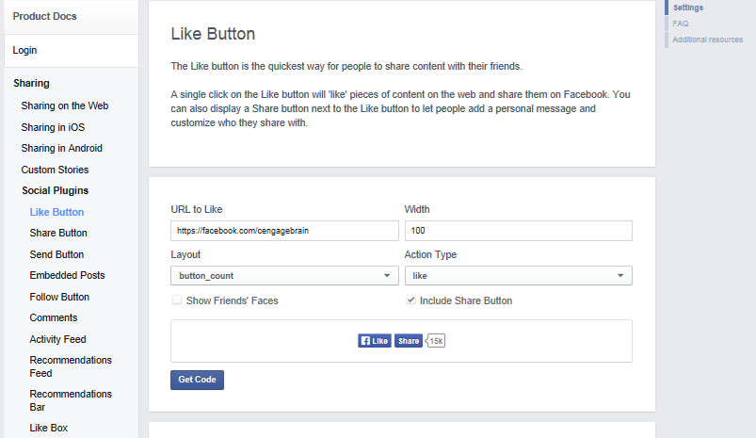

1. Paste code into your html file as before.

Integrate a Twitter account feed

Embeddable timelines make it easy to syndicate any public Twitter timeline to your website with one line of code.

Just like timelines on twitter.com, embeddable timelines are interactive and enable your visitors to reply, Retweet, and favourite Tweets directly from your pages. Users can expand Tweets to see Cards inline, as well as Retweet and favourite counts. An integrated Tweet box encourages users to respond or start new conversations, and the option to auto-expand media brings photos front and center.

These new timeline tools are built specifically for the web, mobile web, and touch devices. They load fast, scale with your traffic, and update in real-time.

## Available Timelines

You can embed a timeline for Tweets from an individual user, a user's favourites, Twitter lists, or any search query or hashtag.

### User

You may create an embedded timeline for any public Twitter user. Each user timeline includes a follow button in the header, allowing website visitors to follow the account with one-click. There's a Tweet box in the footer, enabling visitors to Tweet directly to the user without leaving the page.

I am presuming everyone has a twitter account if not create one please

1. Navigate to https://twitter.com/settings/widgets and click on “create new” to start building your Twitter widget. You may be asked to login along the way.
2. Once you create the widget you can now select your options

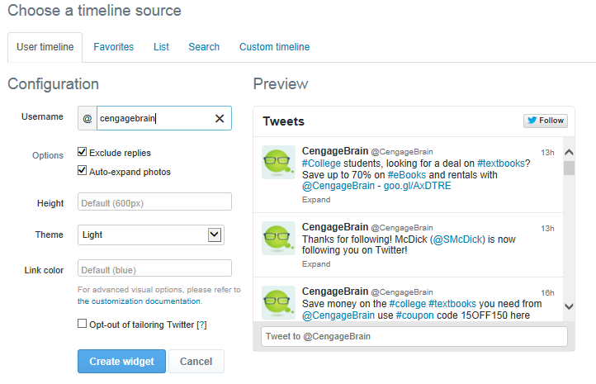

1. After you choose your timeline source (cengagebrain) and options, just click the “create widget” button and Twitter will generate a preview for you and then supply the code you can use just below the preview window. Copy and paste this code into your html file.

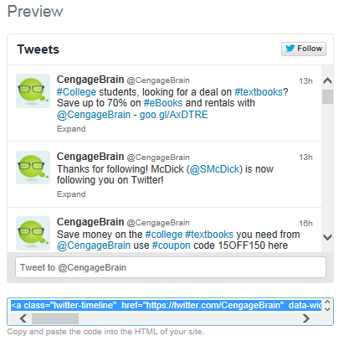

### Favourites

Like the user timeline, a favourite’s timeline may be created for any public Twitter user, and displays that user's favourite Tweets.

List

The list timeline shows Tweets from a specific list of users. The header of the list widget contains the list name, description, and links to the list creator's profile. Retweets by members of the list are included in the timeline. To create a list timeline you must have either created that list yourself, or subscribe to it.

### Search and #hashtag

You may create a search timeline for any query or #hashtag. Searches for a single #hashtag feature a simplified header section, and a “Tweet #hashtag” Tweet box in the footer so that visitors can easily contribute to the conversation directly from your page. Clicking on the #hashtag in the header will open twitter.com search page for that #hashtag. You may also choose to enable “safe mode”, which will exclude Tweets with common profanity and those marked possibly sensitive from appearing on your website.

Add a Twitter hash tag feed

1. Navigate to https://twitter.com/settings/widgets and click on “create new” to start building your Twitter widget.
2. Once you create the widget you can now select your options.



1. After you choose your timeline source (cengagebrain) and options, select Search.

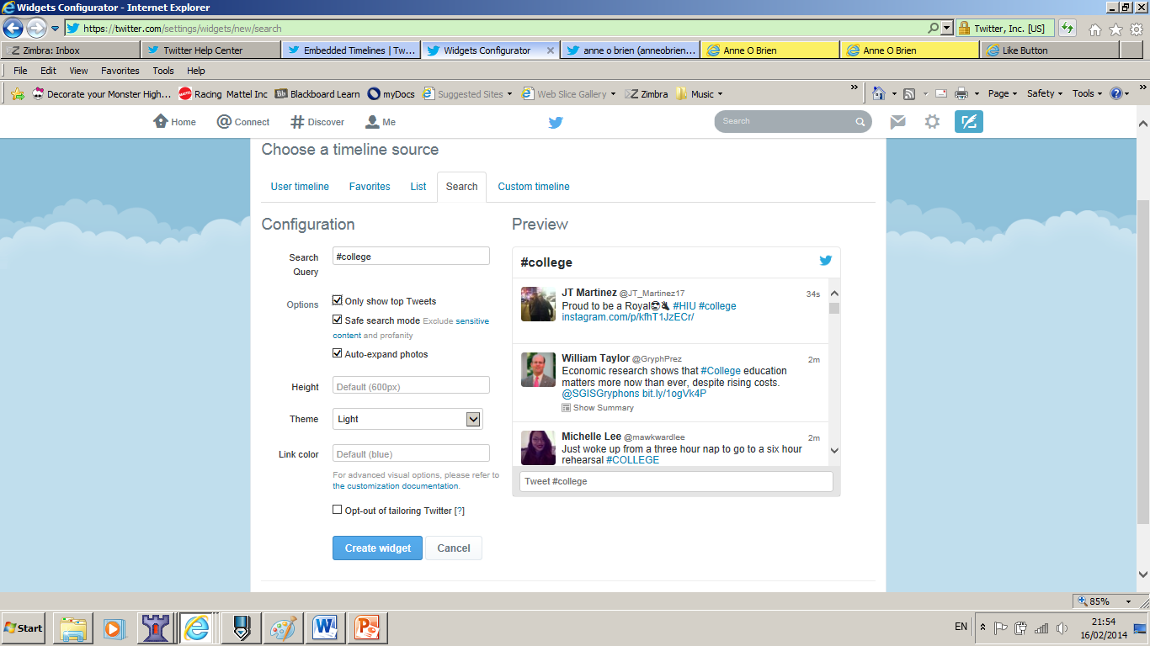

1. Into the Search box enter #college.
2. Click into any of the other fields to update your preview window.
3. You should now only see tweets relating to #college.
4. As before click the create widget button and copy and paste the code into your html file.

Custom

Custom timelines give **you** more control over how Tweets are organized and delivered on the Twitter platform.

Twitter has typically been organized into a few standard timelines: home contains Tweets from accounts you follow, search contains Tweets that match a keyword or term, the user timeline contains Tweets from a specific account, and lists from groups of accounts. These timelines have defined the Twitter experience for the last several years.

Custom timelines are a new type of timeline you control: you create the timeline, give it a name, and select which Tweets to add, either by hand or programmatically using the API. Timelines are public, have their own pages on twitter.com, and can easily be embedded on your website. The rest is up to you.

### How custom timelines work

As a unit, custom timelines operate under the following rules:

* Custom Timelines are created by users.
* Each timeline has a name and description.
* The timeline creator can add any public Tweet to the timeline.
* When new Tweets are added, they appear at the top of the timeline.
* Custom timelines are public, have their own URL on twitter.com, and are viewable by all.

Participate in social bookmarking

There are social networking buttons available for Twitter.

For example, if someone clicks the Twitter button on your site, they can send a short message and a link back to your site through Twitter. That way, all of the Tweeter's friends, and anyone who is looking at all global Tweets, will see what is essentially a word-of-mouth advertisement for your page. What is really nice about this Twitter button is that it automatically appends "via @yourwebsite" at the end of the tweet. This allows for two more features: you can see who is using the Twitter button on your site by looking at your Mentions from Twitter and people who see the tweet can click through to your Twitter stream:

Add the following code to your page to add a twitter bookmarking icon:

<a href="http://twitter.com/share" class="twitter-share-button" data-count="vertical"

data-via= "YourSite" >Tweet</a>